Administracija Operativnih Sustava – Vjezba 3

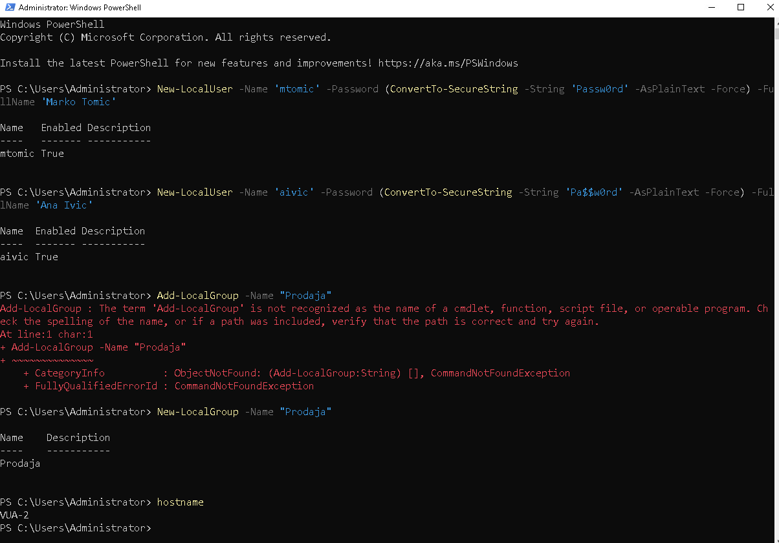

Ne treba se prijaviti zato sto Windows koristi credentiale od korisnika Ane Ivic za pristup SMB shareu koja je takodjer dio grupe “Prodaja”.



